Face Recognition
A Project Report Submitted in Partial Fulfillment of the Requirements for the Award of Degree
Of
Bachelor of Technology
In
Computer Science and Engineering
By
Gourav Rana (11192588)
Neeraj Saini (11192576)
Abhishek Pundir (11192586)

Under the supervision of
Mr. Vikrant Manocha
Department of Computer Science & Engineering



Maharishi Markandeshwar Engineering College, Mullana, Ambala
Maharishi Markandeshwar (Deemed To Be University), Mullana, Ambala, Haryana
Nov 2021

Candidate Declaration

I hereby certify that the work which is being presented in the project entitled “Face Recognition” in fulfillment of the requirement for the award of the degree of Bachelor of Technology in Computer Science and Engineering of M.M Engineering College, Mullana, Ambala, Haryana, India is an authentic record of my own work carried out during a period from January 2021 to December 2021, under the supervision of Mr.Vikrant Manocha. The matter presented in this thesis has not been submitted by me for the award of any other degree of this or any other Institute/University.

Gourav Rana (11192588)
Neeraj Saini (11192576)
Abhishek Pundir (11192586)

This is to certify that the above statement made by the candidate is correct to the best of my knowledge.

Date:

Mr.Vikrant Manocha
(Assistant Professor)
Department of Computer Engineering

Acknowledgement

I wish to express my deep sense of indebtedness and sincerest gratitude to my guide, Mr. Vikrant Manocha, Department of Computer Science & Engineering, M. M. Engineering College, Mullana, Ambala, Haryana, for his invaluable guidance and constructive criticism throughout this dissertation. He has displayed unique tolerance and understanding at every step of progress and encourages me. I deem it my privilege to have carried out my Dissertation work under his able guidance.
I would especially like to thank Dr. Sandip Kumar Goel (Professor and Head), Department of Computer Science & Engineering, M.M Engineering College, Mullana, Ambala, without whom, this work would not have been as it is now.
As a Final Personal Note, I am grateful to my parents, who are inspirational to me in their understanding, patience and constant encouragement.

Gourav Rana (11192588)
Neeraj Saini (11192576)
Abhishek Pundir (11192586)

Supervisor Performa



Abstract
Face recognition, as one of the most successful applications of image analysis, has recently gained significant attention. It is due to availability of feasible technologies, including mobile solutions. Research in automatic face recognition has been conducted since the 1960s, but the problem is still largely unsolved. Last decade has provided significant progress in this area owing to advances in face modelling and analysis techniques. Although systems have been developed for face detection and tracking, reliable face recognition still offers a great challenge to computer vision and pattern recognition researchers. There are several reasons for recent increased interest in face recognition, including rising public concern for security, the need for identity verification in the digital world, face analysis and modelling techniques in multimedia data management and computer entertainment. In this chapter, we have discussed face recognition processing, including major components such as face detection, tracking, alignment and feature extraction, and it points out the technical challenges of building a face recognition system. We focus on the importance of the most successful solutions available so far. The final part of the chapter describes chosen face recognition methods and applications and their potential use in areas not related to face recognition.

TABLE OF CONTENTS

Candidate’s Declaration …………………………………………………………………2
Acknowledgement ………………………….………………………………………….....3
Supervisor Performa……………………….………………………………………….....4
Abstract……………………………………….…………………………………..............5
List of Figures ……………………………………………………………………………7
Chapter 1. Introduction about Project ……….……….……………………….……..8-9
Chapter 2. Platform Requirements …………………………………………………...10
Chapter 3. Objectives of Project Work………………………………………………..11
Chapter 4. Methodology Used ………………………………………………………....12
  - Proposed Algorithm or Technique ……………………………………...12
  - Data flow Diagrams Used ……………………………………………….12
Chapter 5. Results ………………………………………………………………………14
  - Screen shots obtained by running project ……………………………….15
Chapter 6. Future Scope ………………………………………………………………..16.
REFERENCES ...………………………………………………………………………..17
APPENDIX A: Source Code…………………………………………………………….18

List of Figures

Figure No. Figure Caption Page No.

Figure 1 ER-Diagram for Face Recognition 13
Figure 2 How user is identified 13
Figure 3 Program recognize a person 14
Figure 4 Program recognize a person as unknown 14
Figure 5 Program convert color picture to graycolor 15

Chapter 1
  - Introduction

Face is one of the most important biometric features of a human. A human can recognize different faces without difficulty. Yet it is a challenging task to design a robust computer system for face identification. The inadequacy of automated face recognition .systems is especially apparent when compared to our own innate face recognition ability. Human perform face recognition, an extremely complex visual task, almost instantaneously and our own recognition ability is far more robust than any computer's can hope to be.

Human can recognize a familiar individual under very adverse lighting conditions, from varying angles or view points. While research into this area dates back to the 1960's, it is only very recently that acceptable results have been obtained.

However, face recognition is still an area of active research since a completely successful approach or model has not been proposed to solve the face recognition problem.

The next generation surveillance systems are expected to take human face as input pattern and extract useful information such as gender information from it.

1.1 WHAT IS FACE RECOGNITION?
Face recognition is a technology capable of identifying or verifying a subject through an image, video or any audiovisual element of his face. Generally, this identification is used to access an application, system or service.
It is a method of biometric identification that uses that body measures, in this case face and head, to verify the identity of a person through its facial biometric pattern and data. The technology collects a set of unique biometric data of each person associated with their face and facial expression to identify, verify and/or authenticate a person.

1.2 HOW DOES FACE RECOGNITION WORK?
Face recognition systems work by capturing an incoming image from a camera device in a two-dimensional or three-dimensional way depending on the characteristics of the device.
These ones compare the relevant information of the incoming image signal in real-time in photo or video in a database, being much more reliable and secure than the information obtained in a static image. This biometric facial recognition procedure requires an internet connection since the database cannot be located on the capture device as it is hosted on servers.
In this comparison of faces, it analyses mathematically the incoming image without any margin of error and it verifies that the biometric data matches the person who must use the service or is requesting access to an application, system or even building.
Thanks to the use of artificial intelligence (AI) and machine learning technologies, face recognition systems can operate with the highest safety and reliability standards. Similarly, thanks to the integration of these algorithms and computing techniques, the process can be carried out in real-time.

Chapter 2
Platform Requirements

- Technology Used
- Language used: Python
- Library used: Opencv, numpy, os

- System Requirement
- Operating System: Windows
- RAM: 2GB or more memory
- ROM: 120GB or more
- Stable Internet Connection

Chapter 3
OBJECTIVE OF THE PROJECT

The security based flaws in the current auctioning system motivated us to take up this project. We see a scope of improvement in the current system as they are susceptible to a lot of fraudulent activities. The users need to be verified before being able to sell or buy products and that is what we have tried to achieve by the means of this project.

To develop an online auction system which will provide a forum for sellers to meet and interact with buyers, and sell items to interested bidders.

To build a user friendly auctioning website, where user will be able to auction any product which is available nearby or anywhere in the world. By using Online Auction management system it will be easy for auctioneer to make an auction and time saving also. By making auction through this application will help to reach maximum of buyers.

Create a panel where by a sellers receives requests from a buyer and sends back a feedback, an answer to a question or requests to meet the bidder.

Chapter 4
Methodology Used

4.1 Proposed Algorithm or Technique
Haar Cascade classifiers are an effective way for object detection. ... Haar Cascade is a machine learning-based approach where a lot of positive and negative images are used to train the classifier.

Positive images – These images contain the images which we want our classifier to identify.
Negative Images – Images of everything else, which do not contain the object we want to detect.

Requirements:
Make sure you have python, Matplotlib and OpenCV installed on your pc (all the latest versions).

4.2 Data Flow Daigram
ER Diagram
An Entity Relation(ER) Diagram is a specialized graphics that illustrates the interrelationship between entities in a database. ER diagrams often use symbols to represent 3 different types of information. Boxes are commonly used to represent entities. Diamonds are normally used to represent relationships and ovals are used to represent attributes.
An Entity Relationship Model (ERM), in software engineering is an abstract and conceptual representation of data. Entity Relationship modeling is a relational schema database modeling method, used to produce a type of conceptual schema or semantic data model of a system, often a relation database, and its requirements in a top-down fashion

Entity:
Entity is the thing which we want to store information. It is an elementary basic building block of storing information about business process. An entity represents an object defined within the information system about which you want to store information. Entities are distinct things in the enterprise.

Relationships:
A relationship is a named collection or association between entities or used to relate two or more entities with some common attributes or meaningful interaction between the objects.

Attributes:
Attributes are the properties of the entities and relationship, Descriptor of the entity. Attributes are elementary pieces of information attached to an entity.
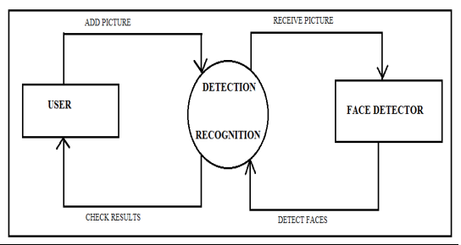
Figure 5 ER-Diagram for Face Recognition
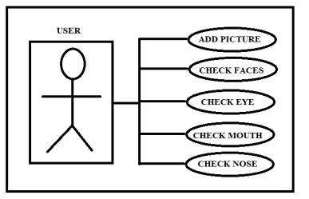
Figure 6 How user is identified
Chapter 5
Results

5.1 APPLICATION SCREENSHOTS

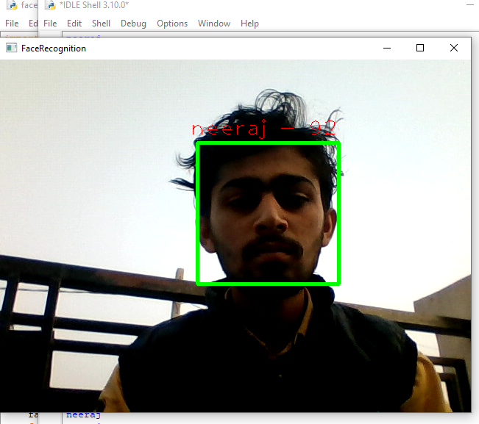
Figure 7 Program recognize a person
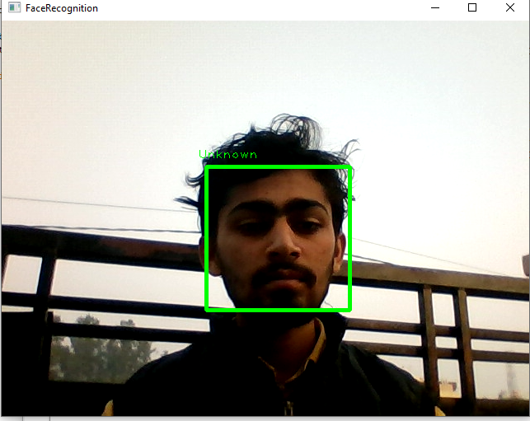
Figure 8 Program recognize a person as unknown

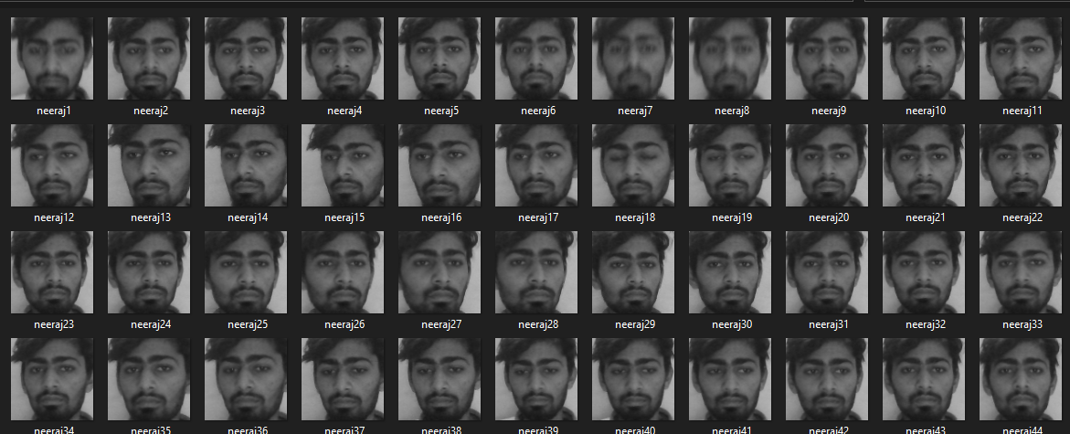
Figure 5 Program convert color picture to graycolor

Chapter 6
FUTURE SCOPE

The world is using facial recognition technology and enjoying its benefits. There is a huge scope of this technology in India and it can help improve the country in various aspects. The technology and its applications can be applied across different segments in the country.

- Reporting duplicate voters in India.
- Passport and visa verification can also be done using this technology.
- Also, driving license verification can be done using the same approach.
- In defence ministry, airports, and all other important places the technology can be used to ensure better surveillance and security.

REFERENCES
https://www.geeksforgeeks.org/python-haar-cascades-for-object-detection/
https://www.rcciit.org/students_projects/projects/cse/2018/GR2.pdf
https://www.youtube.com/watch?v=CSEFY43VrWI&t=54s
https://www.intechopen.com/chapters/51031
https://towardsdatascience.com/real-time-face-recognition-an-end-to-end-project-b738bb0f7348
https://www.youtube.com/watch?v=CSEFY43VrWI

APPENDIX A: Source Code
File 1: code
import cv2
import os

cam = cv2.VideoCapture(0)
cam = cv2.VideoCapture(0,cv2.CAP_DSHOW)
cam.set(3,640)
cam.set(4,480)

face_detector = cv2.CascadeClassifier('haarcascade_frontalface_default.xml')

face_id = input('enter name')
count = 0
while(True):
ret, img = cam.read()
gray = cv2.cvtColor(img, cv2.COLOR_BGR2GRAY)
faces = face_detector.detectMultiScale(gray,1.3,5)

for(x,y,w,h) in faces:
cv2.rectangle(img, (x,y), (x+w,y+h), (255,0,0), 2)
count += 1

cv2.imwrite("dataset/" + str(face_id) + str(count) + ".jpg", gray[y:y+h,x:x+w])

cv2.imshow('image', img)

k = cv2.waitKey(100) & 0xff
if k == 27:
break
elif count >=50:
break
print("exiting")
cam.release()
#cv2.cam.release()
cv2.destroyAllWindows()

File 2: code
import cv2, numpy, os
haar_file = ('haarcascade_frontalface_default.xml')
face_cascade = cv2.CascadeClassifier(haar_file)
datasets = 'dataset'
print('Training...')
(images, labels, names, id) = ([], [], {}, 0)

for (subdirs, dirs, files) in os.walk(datasets):
for subdir in dirs:
names[id] = subdir
subjectpath = os.path.join(datasets, subdir)
for filename in os.listdir(subjectpath):
path = subjectpath + '/' + filename
label = id
images.append(cv2.imread(path, 0))
labels.append(int(label))
id +=1

(images, labels) = [numpy.array(lis) for lis in [images, labels]]
print(images, labels)
(width, height) = (130, 100)
model = cv2.face.LBPHFaceRecognizer_create()
#model = cv2.face.FisherFaceRecognizer_create()

model.train(images,labels)

webcam = cv2.VideoCapture(0)
cnt=0

while True:
(_, im) = webcam.read()
gray = cv2.cvtColor(im, cv2.COLOR_BGR2GRAY)
faces = face_cascade.detectMultiScale(gray, 1.3, 5)
for (x,y,w,h) in faces:
cv2.rectangle(im,(x,y),(x+w,y+h),(255,255,0),2)
face = gray[y:y + h, x:x + w]
face_resize = cv2.resize(face, (width, height))

prediction = model.predict(face_resize)
cv2.rectangle(im, (x, y), (x + w, y + h), (0, 255, 0), 3)
if prediction[1]<800:
cv2.putText(im,'%s - %.0f' % (names[prediction[0]],prediction[1]),(x-10, y-10), cv2.FONT_HERSHEY_PLAIN,2,(0, 0, 255))
print (names[prediction[0]])
cnt=0

else:
cnt+=1
cv2.putText(im,'Unknown',(x-10, y-10), cv2.FONT_HERSHEY_PLAIN,1,(0, 255, 0))
if(cnt>100):
print("Unknown Person")
cv2.imwrite("unKnown.jpg",im)
cnt=0
cv2.imshow('FaceRecognition', im)
key = cv2.waitKey(10)
if key == 27:
break

webcam.release()
cv2.destroyAllWindows()

Conclusion

Face recognition is still a challenging problem in the field of computer vision. It has received a great deal of attention over the past years because of its several applications in various domains. Although there is strong research effort in this area, face recognition systems are far from ideal to perform adequately in all situations form real world. Paper presented a brief survey of issues methods and applications in area of face recognition. There is much work to be done in order to realise methods that reflect how humans recognise faces and optimally make use of the temporal evolution of the appearance of the face for recognition.
GROUP MEMBERS DETAILS

NAME | ROLL NO. | SECTION | E-MAIL | PHONE NO.
Gourav Rana | 11192588 | 5D (D1) | gourav.rana70000@gmail.com | 7015208168
Neeraj Saini | 11192576 | 5D (D1) | neerajsaini2k1@gmail.com | 8683922397
Abhishek Pundir | 11192586 | 5D (D1) | abhishekpundir3399@gmail.com | 9761033091

